Project Proposal

Academic Year 2021

Candidate Details

Index No: 1904205

Name of candidate:

E. R. H. U. M. Gunasekara

Address:

Near the school,

Udamadura,

Nildandahinna.

Contact telephone numbers:

0719696828

Email:

uthpalag2@gmail.com

Supervisor/Advisor Details

|  |  |  |
| --- | --- | --- |
|  | Supervisor 1 (IT Related) | Supervisor 2 (Optional) |
| Name | G S M Perera |  |
| Designation | Senior Software Engineer |  |
| Workplace address | RedBlocks Technologies (pvt) ltd. |  |
| Academic/  professional/  qualifications  and  memberships | BIT, MCTS |  |
| Work experience | 4 Years |  |
| Email: | sandun.eternal@gmail.com |  |
| Phone number/s | 0770249809 |  |

Project Details

Title of Project:

Purchase, Production and Sales Management System for Ceyalac (Pvt) Ltd.

If Repeat Student

Number of Attempt(s): 1

Previous Decision: 



Earlier Project Title:

Name and address of client:

CEYALAC Marketing,

Ingiriya road,

Arukwaththa,

Padukka.

Motivation for project:

* They have manual paper-based system for manage sales, production, purchase and inventory. So, employees have to doing lot of manual works. Then it is very time consumed process.
* Difficult to get how many items are needed to purchase when using the current manual system.
* Harder to determine how many products are needed to produce when using the current manual system.
* When the owner wants a report, the current system is unable to give it timely. Because of the above paper-based manual system.
* Current manual system does not have proper analysis of demand and item requirements.
* Another problem with the manual system is calculating total bill amount.

Objectives and scope of proposed project:

* Managing items data efficiently and up to date
* Managing clients’ data
* Managing suppliers’ data.
* Minimizing manual works and paper usage
* Managing sales’ and purchases’ data meanwhile managing inventory.
* Managing production.
* Managing all payments.
* Generating reports efficiently, timeliness and accurately.

Critical functionalities for project:

* Client management
* Supplier management
* Material management
* Product management
* Sales management
* Production management
* Purchase management
* Disposal management
* Purchase order management
* Report management
* Client payment management
* Supplier payment management.
* Vehicle
* Route
* Route Vehicle Assign

Itemized list of deliverables of the system:

Note: Deliverables are items that you would deliver to the client at the end of the project.

* Complete tested System
* User manual
* User Training

A project plan using Gantt chart (include the work involved in system development as well as writing the dissertation):

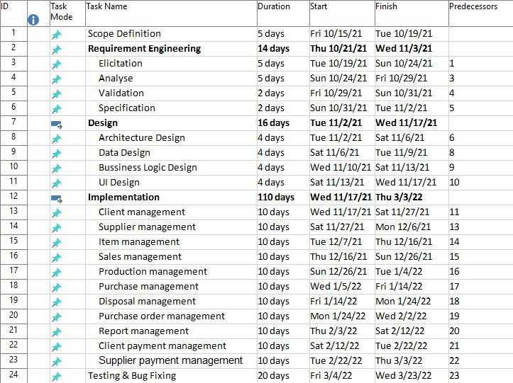

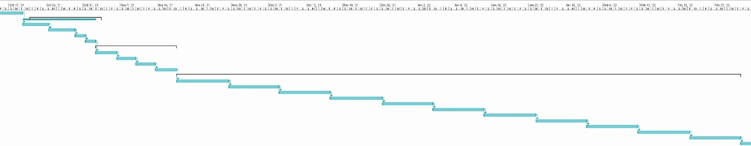

Resource requirements for project (e.g., hardware, software,...):

* Server Computer
  + Hardware
    - Dual-core 64-bit processor
    - 4 GB of memory
    - Up to 5 GB of internal storage
  + Software
    - Windows or Linux.
    - JRE 11
    - MySQL Server 8
    - PHP 7.2.10
    - Apache 2.4.35
* Client Computer or Device
  + Software
    - JavaScript enabled Browser Software (Google Chrome, Firefox, etc.)
* Development Computer
  + Hardware
    - Dual-core 64-bit processor
    - 8 GB of memory
    - 1 TB HDD Hard Disk
  + Software
    - Windows 10
    - MySQL server 8
    - JDK 11
    - Apache 2.4.35
    - MySQL workbench 8.0
    - Google Chrome
    - IntelliJ IDEA 2021.1.1

Proposed way of self-evaluating the success of your system:

* Test plan
  + Unit testing
  + Integrated testing
  + System testing
* Supervisor meeting plan
* Client meeting plan